An Open Source Analysis of the Attack on the Fordow Nuclear Facility

The purpose of this analysis is to provide a real world case study to support the Introduction and Advanced Weaponeering courses provided on a regular basis by Morris Driels to civilian and military audiences in the U.S. and overseas. It draws on only materials presented in these classes, additional topics found in the Weaponeering textbooks and open source data. It represents only the opinion of the author and does not reflect U.S. Government or DoD policy or opinions.

This analysis will consist of the following sections:

1. The attack – public information
2. Data sources
3. The weapon
4. The target
5. Weapon accuracy
6. Weapon penetration through rock
7. Weaponeering the attack
8. Conclusions

1. The Attack

The Table 1 shows the publicly known statements concerning the attack.

|  |  |
| --- | --- |
| Aspect | Details |
| Date & Time | June 22, 2025 (02:10–02:35 IRST; ~23:00 UTC June 21) |
| Aircraft | 7 B‑2 bombers (with decoy flights); supported by fighter escorts |
| Weapons | 14 × GBU‑57 bunker-buster bombs (most on Fordow), plus Tomahawks |
| Damage | Severe structural and underground damage at Fordow; tunnel entrances blocked |
| Expected Impact | Up to ~2-year setback to Iran’s Fordow enrichment program |
| Uranium Stockpiles | Some likely survived; possibly relocated prior to the strike |

## Public data on the Fordow attack

The following are quotes from JCS Gen Daniel Caine reported in USA Today, June 26th 2025.

“A dozen penetrating bombs targeted two ventilation shafts located on opposite sides of Fordow that Iran tried to cover over with concrete in the days leading up to the strike”

“All six bombs went exactly where they were intended to go.”

Caine played reporters a video of a test bomb burrowing into a shaft and exploding and a picture of the hole it left in the ground. “Unlike a normal surface bomb, you won't see an impact crater.” He said

“On each side, the first bomb blew open the shaft and the next four bombs entered at greater than 1,000 feet per second," he said. “The sixth bomb acted as ‘flex weapon’ in case of an issue with one of the preceding bombs.”

2. Data sources

In providing this analysis several open source data will be used frequently, and they will be referred to by the following abbreviations.

a. Chat GBT (CGBT)

b. The Institute for Science and International Security (ISIS)

c. Driels’ weaponeering textbooks (WT)

d. Google Earth Pro (GEP)

3. The Weapon

The principal weapon used in this attack was the 30,000 lb. class GBU-57 Massive Ordnance Penetrator (MOP) delivered by the B-2 bomber which can carry a payload of two. For the purpose of this analysis, the following characteristics will be used ( CGPT).

Total weight of weapon 30000lb.

Weight of explosive 5324 lb.

Length 20.5 ft.

Diameter 31.5 in.

Nose length 48 in.

The weapon is guided by a closely coupled GPS/INS system where the INS is aircraft quality implying little drift over the flight time from release to impact. Since the weapon is a penetrator, it is assumed the weapon approaches the target vertically in order to maximize this effect.

4. The Target

The Fordow facility is a uranium enrichment plant located within a tunnel complex beneath the Kuh-e Siah mountains approximately twenty miles north-east of Tehran. For location purposes in GEP, it is at coordinates 34.885N, 50.996E and the external layout is clearly visible on Google Earth Pro – Figure 1. The external view shows the facility with a perimeter road and two pairs of tunnel portals that give access to the facility, although recent activity suggests possible tunnel access from the south east. External features are dominated by the large white building in the bottom left of the plant known as the support building, thought to house some of the surface air handling equipment.

# Site view showing perimeter road, support building and tunnel portals

P3, P4

P1, P2

An estimate of the internal layout has been obtained (ISIS) and is shown in Figure 2 with an enlarged view of the centrifuge hall showing the ventilation system in Figure 3.

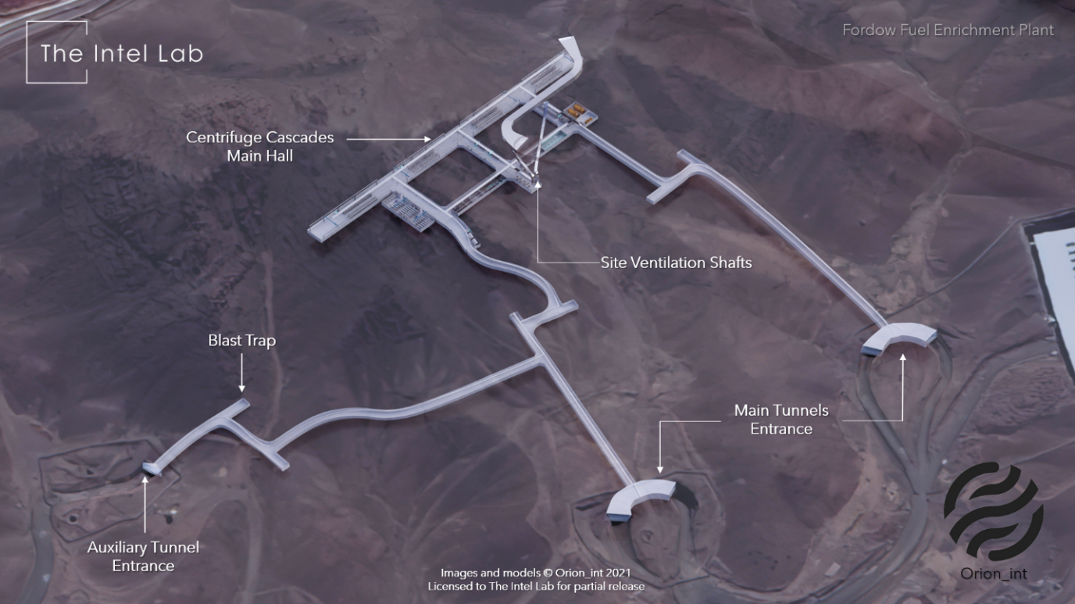

# Estimated layout of facility

# Details of ventilation system

In addition, a dimensioned plan of the main processing area is available – Figure 4.

Centrifuge hall

# Layout of main processing areas

This shows the main centrifuge hall measuring 250m by 13m connected by three 38m by 10m tunnels connected to a parallel chamber approximately 125m long and 10m wide. Protruding out from the center connecting tunnel is a blind chamber thought to contain ventilation equipment at the end of which is a circle possibly representing the bottom of a ventilation shaft to the surface. An expanded view of this area is shown in Figure 5 with some estimated dimensions.

These areas are connected to the outside by circuitous tunnels with perpendicular offshoots which may serve as both storage areas and blast traps. These are designed to attenuate and deflect any large shockwaves caused by external detonations in the vicinity of the portals, and traveling down the tunnels.

# Expanded view of assumed location of central ventilation shaft

Given the above data, we can overlay the diagram of the main processing facility onto a GEP image of the terrain as shown in Figure 6. In addition, a number of placeholders are located around the perimeter road in order to show the elevation of each point.

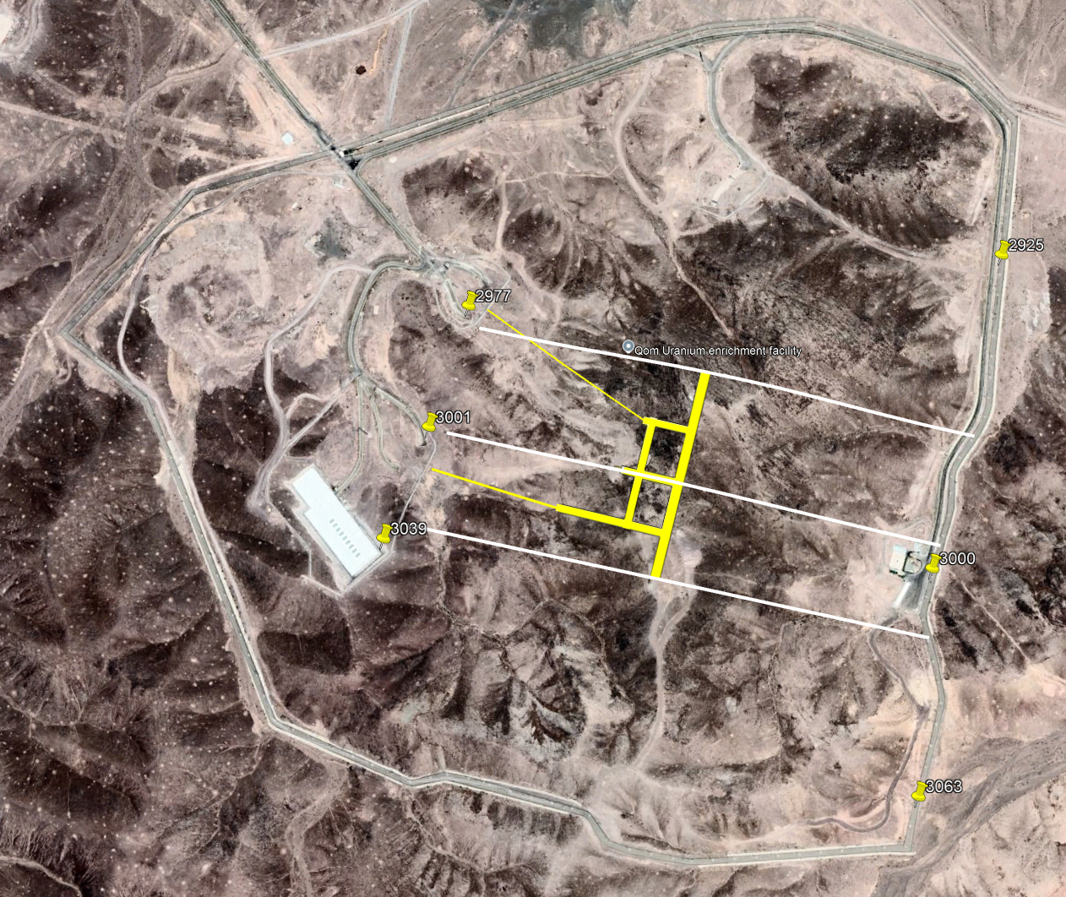

# Main facility features overlaid on terrain with three vertical sections drawn

Three parallel sections are drawn through the facility as shown in Figure 7. Assuming a horizontal data of 3000’ – the average elevation of the perimeter road – the following data may be determined.

1. The maximum elevation of rock above the datum is about 140’.

2. The average slope of the terrain is 10%, or 15 degrees.

3. Estimates of the height of the centrifuge hall are 20’-33’ (CGBT) which means there is an overburden of about 110’-120’ of rock.

# Vertical sections across the facility – north, center and south

It appears that there may be ventilation shafts connecting the underground facility with the surface at the location shown in figure 5 and at the southern end of the main centrifuge shown in Figure 6.

5. Weapon Accuracy.

Knowing the accuracy of the weapon is one critical factor in determining the outcome of any precision strike. The GBU-57 is a large, conventional weapon guided by a coupled GPS/INS system designed such that if the GPS receiver detects it is being jammed, control is transferred to the INS system for terminal guidance.

Assuming GPS coordinated are stored or handed off by the B-2 bomber at release, a rough estimate of time of fall from 50,000’ release is about 55 seconds. Even if GPS jamming occurred at the instant of release, the drift of the aircraft quality INS over this interval will be negligible, therefore local GPS accuracy may be assumed.

Although it is customary to assign a single number to a weapon accuracy, such as the circular error probable (CEP) it will be shown later that errors in calculating the effectiveness of the weapon will occur if multiple weapons are directed against the same target. Instead, the principal factors contributing to the total weapon accuracy have to be considered. GPS/INS weapons will maneuver to a specified target with a total error that is determined by three independent components:

1. NAV - The inherent accuracy of the on-board GPS system, termed the navigation error. It is the accuracy with which the weapon can determine its GPS coordinates relative to the WGS-84 ellipsoid.
2. G&C - The ability of the guidance and control system to maneuver the weapon to the target coordinates, the guidance and control error.
3. TLE - The error with which the coordinates of the target are “known”, termed the target location error.

Estimates of all three error sources in both horizontal and vertical directions are needed to predict the total accuracy of GPS guided munitions.

Since the three error sources are independent, we may combine them in an RSS process and write the equation for the total error as follows.



In this equation, the error components must be in consistent units such as standard deviations (sigma), CEP (CE50) or CE90.

5a. Navigation (NAV) Error

This error is essentially – how accurate are the GPS coordinates measured by the onboard GPS receiver? Unfortunately, this is not a fixed number because it depends on the geometry of the satellites broadcasting the signals detected by the receiver and since this varies with time and location, so will the NAV error. It is usually expressed in the form



In this equation:

1. UERE is the User Expected Ranging Error which is the accuracy the receiver can measure the distance to a broadcasting satellite, sometimes called the pseudorange, For a high quality military system this may be the order of 0.5m.

2. DOP is the Dilution of Precision the principle components of which are HDOP (horizontal DOP) and VDOP (vertical DOP), and it is these quantities that vary with location on the Earth’s surface and the time of attack. This was approximately at 2300 UTC on June 21st 2025. Figure 8 shows a Trimble generated 24 hour DOP history for the target location spanning the time of the attack, showing values of HDOP=0.42 and VDOP=0.66.

# GPS DOP values at the target location at 2300 UTC, June 21st 2025.

Knowing the UERE and DOP values allows us to calculate the NAV errors, although this will be deferred until all error sources have been determined.

5b. Guidance and Control (G&C) Error

This represents the ability of the control surfaces on the weapon to change its trajectory in order to guide it to the target and this is usually specified by the weapon manufacturer. It will not be available in open sources for the GBU-57. Since the weapon is designed to impact vertically, we may assume the guidance has some time to correct the flight trajectory and only small corrections are necessary. CGBT estimates the G&C horizontal errors to be equivalent to a CEP<1-2m, which is consistent with other GPS/INS weapons dropped from high altitude.

5c. Target Location Error

Operationally, TLE is expressed as a category or CAT number, usually in the range 1-6 where 1 corresponds to the most accurate target coordinates and 6 refers to the least accurate. Table 2 shows the ranges of horizontal and vertical dispersion associated with each CAT number along with mid-range point values.

|  |  |  |  |  |
| --- | --- | --- | --- | --- |
| Category (CAT) | Horizontal CE90 (m) | Vertical LE90 (m) | H value (m) | H value (ft) |
| 1 | 0-6 | 0-3 | 3 | 9.8 |
| 2 | 6-15 | 3-5 | 10.5 | 34.4 |
| 3 | 15-30 | 5-7 | 22.5 | 73.8 |
| 4 | 30-91 | 7-9 | 60.5 | 198.4 |
| 5 | 91-305 | 9-15 | 198 | 649.4 |
| 6 | >305 | >15 | N/A | N/A |

## TLE accuracy

The table shows in the ground plane values of circular error probable for the 90% of impacts while the vertical dispersion is a 90% normal, linear distribution. It may be assumed that for these attacks TLE CAT 1 quality target coordinates are available. Putting all this data into a GPS accuracy spreadsheet (WT) gives the result in Figure 9. The inputs are the green cells.



# Spreadsheet to calculate components of GPS accuracy

Note the following:

1. Although the weapon impacts vertically on an average slope of 15 degrees, the impact angle should be 75 degrees, relative to the striking surface, however this effect is minimal and will be ignored.
2. The total CEP=5.75’ which is consistent with published data for this and other GPS/INS weapons impacting vertically.
3. Of primary interest are the CEP values of each of the three components:
   1. NAV CEP = 1.26’
   2. G&C CEP = 1.50’
   3. TLE CEP = 5.40’

When calculating effectiveness, each of these have to be considered separately since whatever the value of the NAV and TLE errors, they affect all weapons by the same amount, but the G&C errors will be different for each weapon released (see later).

6. Weapon penetration through rock

In reviewing figure 4, it would make sense to select aimpoints spaced along the length of the main centrifuge hall, however that requires the GBU-57 to penetrate about 120’ of rock. Can this be achieved?

Much has been written regarding the ability of the GBU-57 to penetrate soil, rock and concrete[1] so in this study we will use the DoD standard methodology attributable to Sandia National Laboratory and published by C.W. Young[2]. These equations were originally published in 1967 with updates in 1988 and 1997, and it is the latest report that is used here. The relevant equation is



Where

|  |  |  |  |
| --- | --- | --- | --- |
| D | = | distance penetrated (ft) |  |
| S | = | penetration resistance factor |  |
| N | = | weapon nose shape constant |  |
| v | = | weapon impact velocity (ft/sec) | |
| W | = | bomb weight at penetration (lb.) | |
| A | = | bomb cross sectional area (sq in) | |

The weapon nose shape constant is given, for an ogive, by the following:



and *R*= nose length/bomb diameter

An upper limit on impact velocity may be obtained from a simple energy balance, the potential energy at release, say 50,000’ being converted to kinetic energy



In practice, energy is lost due to air resistance, so a value of 1500 ft/sec is suggested (CGBT).

An accurate assessment of the weapon penetration depends on an accurate assessment of the rock through which it is passing. Rocks may be categorized by their unconfined compressive strength (UCS) given the symbol f’c. Taking granite as an example, a 1” cube taken from a kitchen countertop would represent an ideal test sample, and after placing in a compression testing machine, increasing the compressive force until failure occurs, a value somewhere between 100 and 250 MPa would be obtained, depending on the type of granite.

However, naturally occurring granite does not look like a kitchen countertop, is has cracks, fissures and voids running through it and these can greatly reduce the rock strength. This feature is captured in the concept of “rock quality” Q which is a subjective number in the range 0.1 to 1.0 where 1.0 represents a fault free sample and 0.1 represents poor quality rock with many faults.

This equation applies equally to concrete and rock, however soil penetration is usually modeled using the Poncelet equations (WT). What distinguishes rock from concrete is the selection of the S number, representing the “penetrability” of the material. Young provides the following equation for the S number for rock.



Where the unconfined compressive strength of the rock is in PSI. CGBT provides the data in Table 3 for different rock types



## Unconfined compressive strength of rock

The composition of the Kuh-e Siah mountain is essentially limestone with layers of Dolomite so take the worst case, which is the stronger material, Dolomite, and take a mean value for strength of 20,000 psi. The spreadsheet shown in Figure 10 provides the penetration depth D.



# Calculating penetration of rock using Sandia equations

Here a rock quality Q has been set to 0.5 but varying it over the possible range of values gives D=16.28’ for Q=1 to D=32.48’ for Q=0.1. It seems therefore that it is unlikely that a GBU-57 could penetrate the 100’+ overburden of the main centrifuge hall.

There is a short video of a GBU-57 test which shows penetration into a tunnel and the resulting detonation – see Figure 11.

GBU-57

# GBU-57 impact during tunnel test

Figure 11 shows the impact above the tunnel where the thickness of rock to be penetrated is a little larger than one bomb length, say 25’. No information regarding the type or quality of the rock is provided but a post penetration image of the crater is shown in Figure 12. In the video the weapon clearly penetrates into the tunnel and detonates.

# A hole in the ground AI-generated content may be incorrect. Penetration crater

This figure shows stratified rock layers through which the rock passes although it is not known if this stratification is present prior to the impact.

As a point of reference the PC Effects program (WT) may be used to illustrate how far a GBU-57 can penetrate through layers of different materials, namely soil, concrete and rock. To do this a layer thickness of 350’ is selected to ensure perforation does not occur, with the results shown in Figure 13.

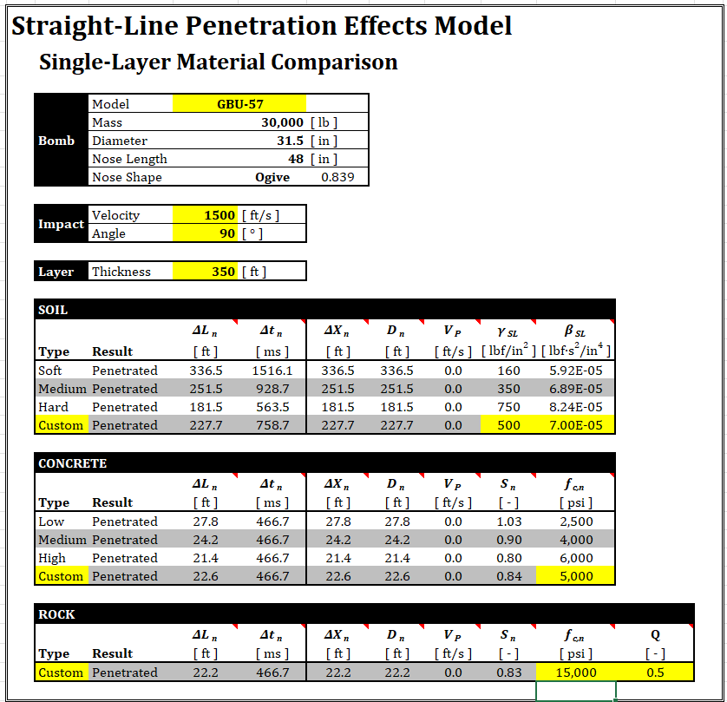

# Comparison of GBU-57 penetration through different materials

From this it is seen that

1. Penetration through soil is 181.5’ to 336.5’ depending on the hardness of the soil.
2. Penetration through 5000 psi concrete is 22.6’.
3. Penetration though 15,000 psi rock with quality Q= 50% is 22.2’.

Note that higher fidelity penetration models such as PENCURV3D (WT) might give different results compared to PC Effects but since this model is not available in the public domain, differences are hard to assess.

7. Weaponeering the Attack

Since the GBU-57 may not be able to penetrate the rock above the centrifuge hall, it seems the plan of attack would be to try and deliver a bomb down the ventilation shaft(s), resulting in the desired mean points of impact (DMPI) shown in Figure 14.

DMPI1

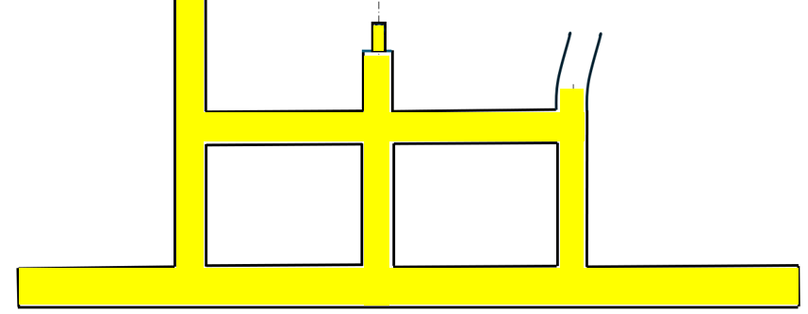

DMPI2

# Aimpoints for the attack

The problems to be solved therefore are:

1. If multiple weapons are used and the accuracy of the weapon is known, what is the probability at least one weapon will enter a vertical ventilation shaft of given diameter?
2. If the attack is mounted against two vertical shafts, what is the probability a single bomb will go down at least one of the shafts?

Note that these criteria address only the probability of hitting the ventilation shaft and do not answer the question of what damage would result if this is accomplished. It is therefore assumed that if the bomb can arrive at the bottom of the shaft and detonate, sufficient damage to the centrifuges will result.

The probability of having a bomb enter the ventilation shaft is solved using a stochastic, Monte Carlo approach involving the following steps.

1. Each of the three accuracy CEPs are converted to equivalent standard deviations in range and deflection using the equation (WT):



1. A random draw in range and deflection is taken for the NAV error using a zero mean and the NAV sigma values.
2. Another random draw in range and deflection is taken for the TLE error using a zero mean and the TLE sigma values
3. The x coordinates and y coordinates for steps 2 and 3 are algebraically added to get the mean point of impact (MPI) for all the bombs dropped.
4. For each bomb, a random draw in range and deflection is taken for the G&C error using a zero mean and the G&C sigma values. These are then added to the MPI (x, y) values to obtain the impact point of each weapon.
5. If the impact point of the weapon is inside a circle representing the ventilation shaft then the bomb is considered to have entered and a target kill is reported.
6. Steps 2-7 are repeated a large number of times varying the three accuracy components and the average number of target kills calculated. This result is the expected probability of at least one weapon entering the shaft.

The spreadsheet program is shown in Figure 15 where the three accuracies are transferred from Figure 9 and a shaft diameter of 6’ is assumed.



# Spreadsheet to calculate effectiveness

A single iteration where all four bombs enter the shaft is shown in Figure 16 while another iteration where no bombs enter the shaft is shown in Figure 17. The bomb diameter of 31.5” is also shown in the diagrams, centered on each impact point.

# Sample iteration where four bombs enter the shaft

# Sample iteration where no bombs enter the shaft

For the data shown in the program, the probability of at least one bomb entering the vent is 31.8%. This result obviously depends on the diameter of the shaft and Figure 18 shows this trend with the “Separate accuracy” plot.

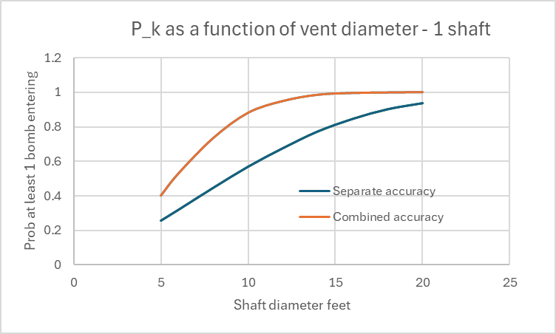

# Probability of 1 bomb entering shaft vs. shaft diameter

It is worth noting that if all error CEP values are combined to give a total CEP=5.7’ and a Monte Carlo simulation using just this one accuracy value, a different result is obtained as shown in Figure 18 with the “Combined accuracy” plot.

Considering the attack was against two shafts, the probability of one bomb passing though one of two possible, identical shafts is obtained from the survivor rule.



Again, this is plotted in Figure 19 against the shaft diameter for two cases, one where the accuracy parameters are kept separate (correct) and one where they are combined (incorrect).

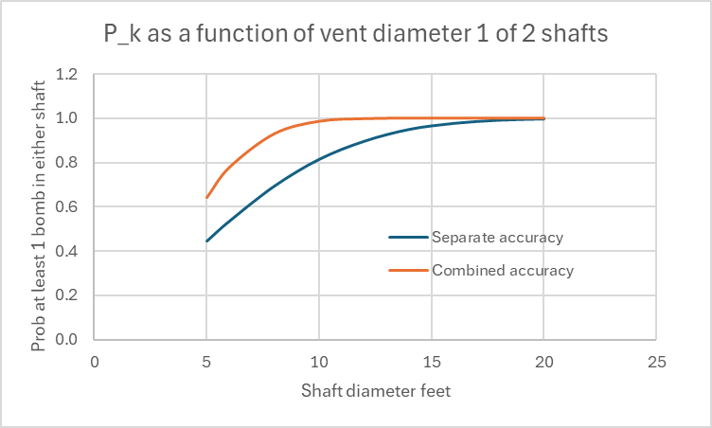

# Probability of 1 bomb entering at least one of two shafts

The total accuracy of 5.7’ is correct, but the methodology using this single accuracy to calculate the probability of a bomb entering the ventilation shaft is not correct if multiple weapons are used to attack the target. This is because the impact points using a single CEP for one Monte Carlo simulation look like Figure 20, centered around the aimpoint rather than Figure 16 or Figure 17 where the error components are kept separate and the impacts are centered around the MPI.

# Impact points using a single CEP

8. Post attack analysis

Some imagery is available showing impact points resulting from the targeting of the two ventilation shafts, Figure 21.

# Post attack satellite imagery

This shows the attack on the two DMPIs shown in Figure 14 and suggests two smaller impact craters and one large crater perhaps where two bombs have impacted sufficiently close to form a single crater. Unfortunately, the image does not indicate the GPS coordinates of the aimpoints, but these impact points are consistent with Figure 16 and Figure 17.

8. Conclusions

1. Using the models shown, it seems unlikely that a GBU-57 could penetrate the overburden of the main centrifuge hall of the site, therefore the attack should focus on an easier path from the surface to that part of the facility. Based on post attack satellite imagery, this seems to be the tactic employed.

2. It is possible that the ventilation shafts may provide such a path although their geometry and how they connect the surface with the underground areas is not available in the open literature. We assume they are vertical and circular in cross-section.

3. Six bombs were assigned to each of two shafts, one to remove a recently constructed concrete cap, four to attack the ventilation shaft and one “spare”. Therefore the problem reduces to two open shafts attacked with four bombs each.

4. Assuming the shafts are circular, vertical and provide no substantial impediment to the passage of a bomb, an estimate may be made of the probability a single bomb arriving at the bottom of the shaft, based on the shaft diameter – see Figure 18. Similarly, the probability of a single bomb passing down one or other of the two shafts may be calculated – see Figure 19.

5. To arrive at the correct answer, those components of weapon accuracy that apply equally to all weapons in the attack must be kept separate from those error components which apply to each bomb individually, as shown in Figure 18 and Figure 19.

1. According to a [2012 Congressional Research Service briefing](https://nsarchive2.gwu.edu/NSAEBB/NSAEBB439/docs/doc_62.PDF), the GBU-57/B has been reported to burrow through 200 feet of concrete or bedrock with a density of 5,000 pounds per square inch (comparable to the strength of bridge decks)
2. Penetration Equations, Young, C. W., Contractor report SAND97-2426, New Mexico, October 1997.